LUNENBURG CEMETERY COMMISSION

17 Main Street, P. O. Box 135
Lunenburg, MA 01462
978-582-4144 Fax 978-582-4148

Mike Clark, Chair
David Dorren, Vice-Chair
Donna Landry, Clerk

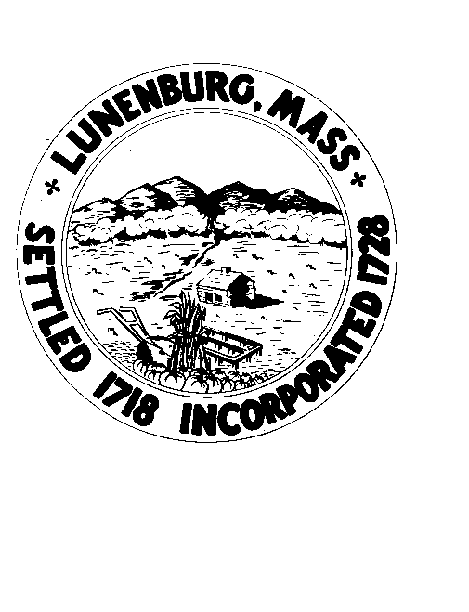

Meeting Notice

Thursday, July 3, 2025 – 6:00PM
Lunenburg Public Library – Sudolnik Conference Room

Agenda

In accordance with the requirement of the Open Meeting Law, please be advised that this meeting is being recorded and broadcast live over the Lunenburg Public Access channel, on Facebook Live on the Public Access Facebook page (https://www.facebook.com/Lunenburg-Public-Access-Cable-157427270975305/ ) and will be uploaded to the Lunenburg Access YouTube after the meeting. This meeting will be held in-person at the location provided on this notice. Members of the public are welcome to attend this in-person meeting. Please note that while an option for remote attendance and/or participation is being provided as a courtesy to the public, the meeting will not be suspended or terminated if technological problems interrupt the virtual broadcast, unless otherwise required by law. Members of the public with particular interest in any specific item on this agenda should make plans for in-person vs. virtual attendance accordingly.
Remote Participation – Join Zoom Meeting: https://us02web.zoom.us/j/7927370353?omn=84028055291– Meeting ID: 792 737 0353
Agenda
1. Stand for Pledge of Allegiance.
2. Motion & approve Invoices for Memorial Day preparations
3. New items for future discussion
4. Other items (not to be voted on)
5. Public Comment
6. Adjourn

