MEMORANDUM – OFFICE OF THE TOWN MANAGER

17 Main Street * Lunenburg, MA 01642 * (978) 582-4144
cterenzini@lunenburgma.gov * www.lunenburgma.gov

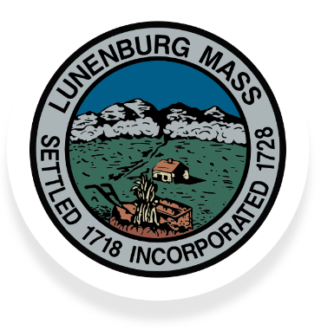
TO: Select Board

FROM: Carter Terenzini, Interim Town Manager

RE: Weekly Report

DATE: December 10, 2024

CC: Department Heads; file
______________________________________________________________________________

General Updates

I taped a Talk of the Town with Chris Reilly, our Land Use Administrator. As of this writing we still await DOR to sign off on the free cash (Estimated at $1.25M) but were able to get a final tax rate set at $14.36 ($.01 less than anticipated). We anticipate the tax bills will be mailed out next week.

I met with the Food Pantry representative to work on their contract (redline was received today). I met with the Village at Flat Hill representative to identify final documents they needed to submit for processing their $12.5k. I also met with the owners of the property where the “found” cemetery is located to hear their concerns and questions. I’ll get those pushed out to the Historic Commission and others this week. Once we have that – and some other info in hand – we can have the next discussion. I’ve set a meeting with Town Counsel to review the potential APDC/HC merger.

Project Updates

Library Teen Room has been executed. Town Hall Roof Replacement and Chimney Restoration contract has been issued. The Contractor understands we want the chimneys done first and agrees. We have had a request by a commission member to view the chimneys. I have authorized Facilities to allow this provided, it is done with a boom truck, full safety harness, and is accompanied by the Contractor who shall require a release form. Otherwise, we will not be able to allow it. Ritter Building Roof contractor met with us this morning to review the scope of the work and review his bid costing. He says he feels comfortable with both and will give us a final answer tomorrow.

DPW Floor Project started today. DPW Roof Project expected to start next week.

ARPA orders are all moving forward. There are some minor variations in pricing as final quotes come in. We are going back thru the full capital programs of FY ’22 & ’23 to make sure all actions are coordinated as a full package. We do not see any challenges with getting all fully
Weekly Report
December 10, 2024
Page 2

committed by the 12/31 deadline but have put a hold on other projects to concentrate on these.

Recruitment

Pending the Sewer Commission’s action tonite, we have a Sewer Business Manager with a starting date of 01/06. Our other current vacancies are:

- PAC Videographer 2 to 10 hrs/wk.
- Assistant to the Sewer Business Manager 19 hrs/wk.
- Police Officer (FT) (Interviews are on 12/16)
- Network Administrator (FT)

All positions are open until filled and the applications for Police Officer will be held on file for filling any vacancy occurring within the next six months.

Boards and Committee Vacancies:

We have a flyer seeking volunteers for our various boards and committees going into the tax bills being mailed on or about mid next week. The current vacancies are:

Agricultural Commission – 1 vacancy
Architectural Preservation District Commission – 1 Vacancy
Board of Health – 1 vacancy
Conservation Commission – 1 Vacancy
Cultural Council – 1 Vacancies (2 await taking the oath)
Finance Committee – 1 Vacancy
Green Communities Committee – 2 Vacancies
Historical Commission – 2 Vacancies
Library Board of Trustees – 1 Vacancy
Master Plan Steering Committee – 1 Vacancy/2 Representative Vacancies
Personnel Committee – 5 Vacancies
Public Access Cable Committee (PACC) – 1 vacancy
Stormwater Task Force – 1 Vacancy
Zoning Board of Appeals – 1 Vacancy

